* **Locations with the Highest Number of Remote Work Opportunities**

select location, sum(remote_allowed) AS TotalRemoteJobs from job_postings

where remote_allowed = 1 GROUP by location ORDER BY 2 desc, location desc

limit 5

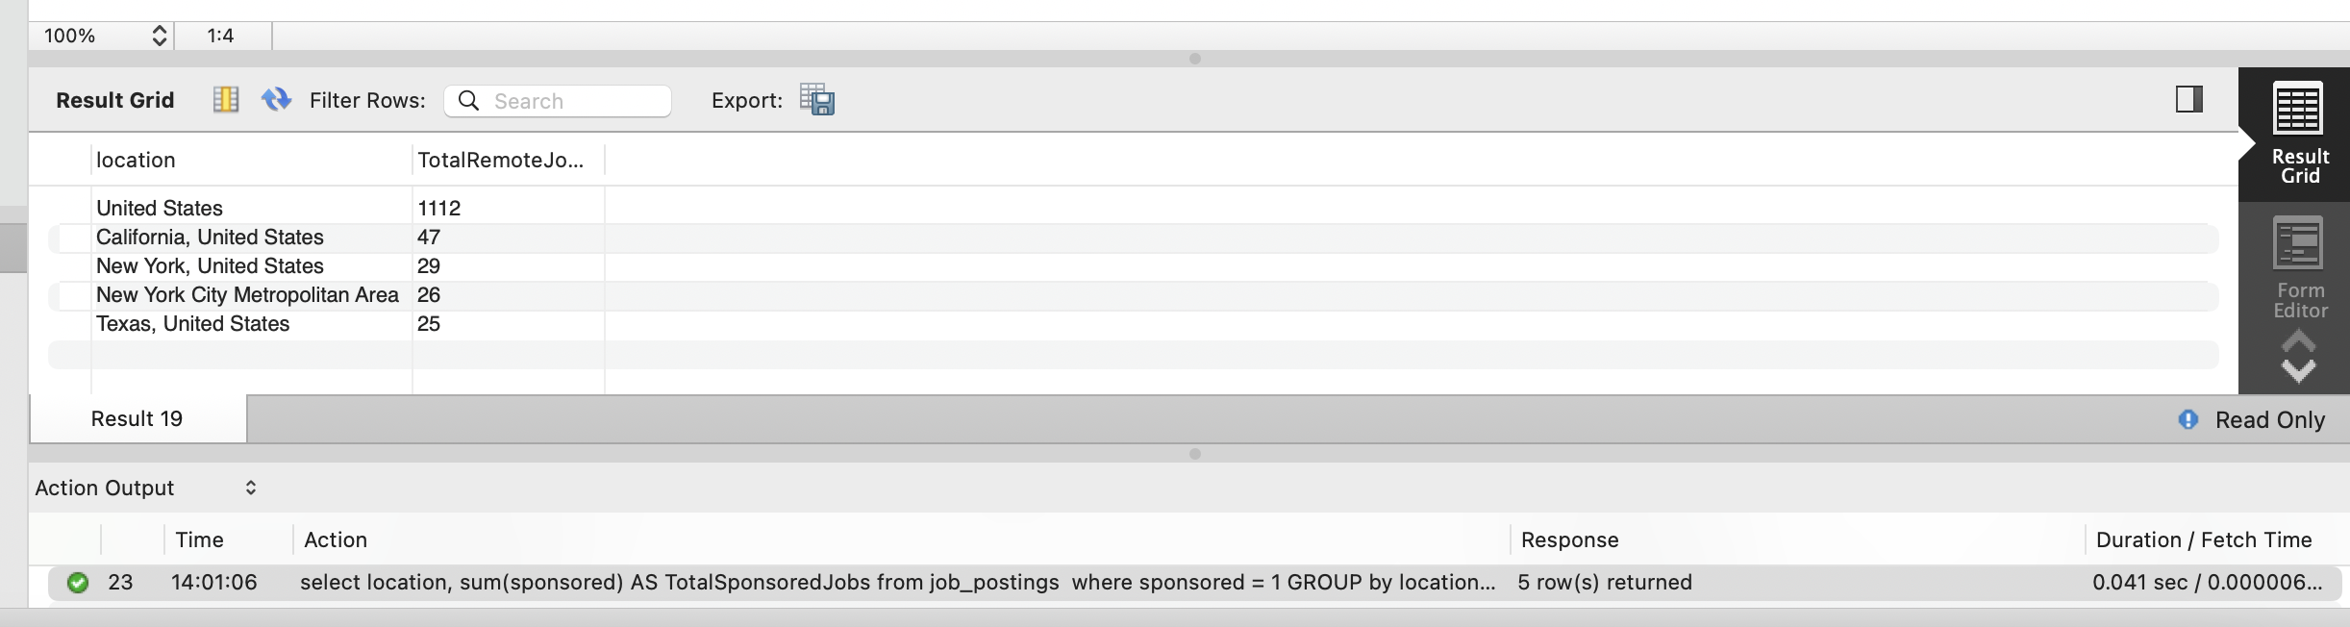

* **Top 5 Locations with the Sponsored Job Postings**

select location, sum(sponsored) AS TotalSponsoredJobs from job_postings

where sponsored = 1 GROUP by location ORDER BY 2 desc, location desc

limit 5

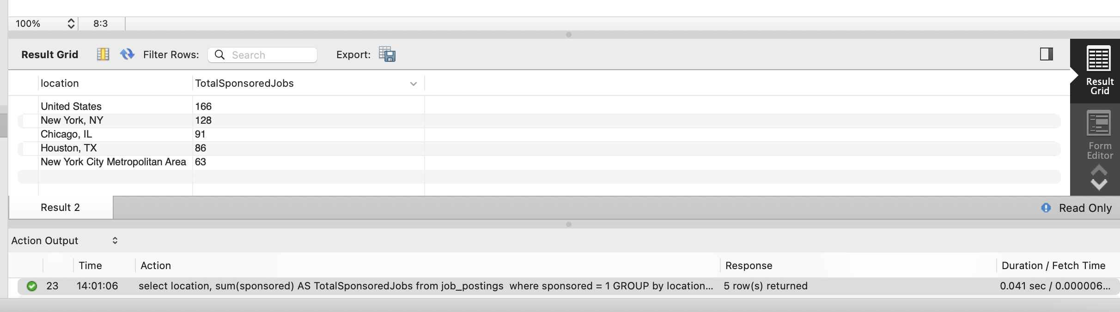

* **Company with highest employee count where specialties is “analytics”.**

SELECT DISTINCT C.name, EC.employee_count AS CompanySize, CS.speciality FROM employee_counts EC JOIN companies C ON EC.company_id = C.company_id

JOIN company_specialities CS ON CS.company_id = C.company_id

WHERE CS.speciality = 'analytics'

